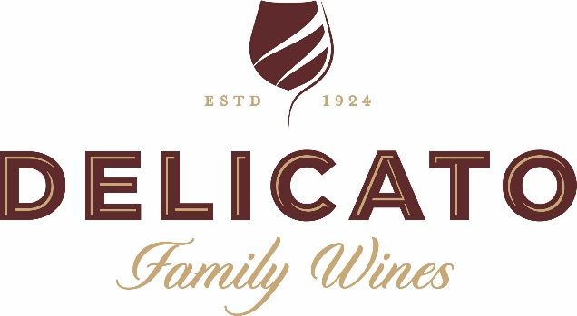

**New Zealand California Market Immersion Visit**

**Black Stallion Estate Winery & Vineyard**

**June 13, 2023**

**9:30 a.m. – 11:30 a.m.**

**Address: 4089 Silverado Trail, Napa, CA 94558**

**Delicato Family Wines Attendees:**

* **Host: Lindsay Moorhead, Director, ESG & Sustainability**
  + **Cell: 1-707-339-6404**
  + **Email:** [**lindsay.moorhead@delicato.com**](mailto:lindsay.moorhead@delicato.com)
* **David Hayman, VP, Winegrowing**
* **Ralf Holdenreid, Director, Winemaking**
* **Grant Cremers, General Manager, Winery Operations- Central Coast**
* **Brent Dodd, Director, Corporate Communications**
* **Dianna Barron, Hospitality & Events Manager, Black Stallion Estate Winery**
  + **Cell: 1-530-796-8034 (please contact if you cannot reach Lindsay M.)**

|  |  |  |  |
| --- | --- | --- | --- |
| **TIME** | | **TOPIC** | **LEAD** |
| 9:30 a.m. | 9:45 a.m. | Arrive @ Black Stallion/ Welcome & Intros | Lindsay Moorhead & Everyone |
| 9:45 a.m. | 10:30 a.m. | Walking Tour of Black Stallion Estate Vineyard & Winery | Grant Cremers & Ralf Holdenreid |
| 10:30 a.m. | 11:00 a.m. | Standing Tasting | Ralf Holdenreid |
| 11:00 a.m. | 11:15 a.m. | Wrap-up & Conclusion | Lindsay Moorhead |
| 11:15 a.m. | 11:30 a.m. | Loading Up/ Departure for To Kalon Vineyard – Constellation Brands | |